**NUMPY EXERCISES**

**Exercise 1:** Create a 5X2 integer array from a range between 100 to 200 such that the difference between each element is 10

Expected Output:

Creating 5X2 array using numpy.arange

[[100 110]

[120 130]

[140 150]

[160 170]

[180 190]]

**Exercise 2:** Following is the provided numPy array. return array of items in the third column from all rows

import numpy

sampleArray = numpy.array([[11 ,22, 33], [44, 55, 66], [77, 88, 99]])

Expected Output:

Printing Input Array

[[11 22 33]

[44 55 66]

[77 88 99]]

Printing array of items in the third column from all rows

[33 66 99]

**Exercise 3:** Add the following two NumPy arrays and Modify a result array by calculating the square of each element

import numpy

arrayOne = numpy.array([[5, 6, 9], [21 ,18, 27]])

arrayTwo = numpy.array([[15 ,33, 24], [4 ,7, 1]])

Expected Output:

addition of two arrays is

[[20 39 33]

[25 25 28]]

Result array after calculating the square root of all elements

[[ 400 1521 1089]

[ 625 625 784]]

**PANDAS EXERCISES**

**This exercise contains 10 questions. The solution provided for each question. Each question includes a specific Pandas topic you need to learn, When you complete each question you get more familiar with data analysis using pandas.**

**DATASET:**

**Question 1:** From given data set print first and last five rows

**Question 2:** Clean data and update the CSV file

Replace all column values which contain ‘?’ and n.a with NaN.

**Question 3:** Find the most expensive car company name

Print the most expensive car’s company name and price.

**Question 4:** Print All Toyota Cars details

**Question 5:** Count total cars per company

**Question 6:** Find each company’s Highest price car

**Question 7:** Find the average mileage of each car making company

**Question 8:** Sort all cars by Price column

**Question 9:** Concatenate two data frames using the following conditions

Create two data frames using the following two Dicts, Concatenate those two data frames and create a key for each data frame.

GermanCars = {'Company': ['Ford', 'Mercedes', 'BMV', 'Audi'], 'Price': [23845, 171995, 135925 , 71400]}

japaneseCars = {'Company': ['Toyota', 'Honda', 'Nissan', 'Mitsubishi '], 'Price': [29995, 23600, 61500 , 58900]}

**Question 10:** Merge two data frames using the following condition

Create two data frames using the following two Dicts, Merge two data frames, and append the second data frame as a new column to the first data frame.

Car_Price = {'Company': ['Toyota', 'Honda', 'BMV', 'Audi'], 'Price': [23845, 17995, 135925 , 71400]}

car_Horsepower = {'Company': ['Toyota', 'Honda', 'BMV', 'Audi'], 'horsepower': [141, 80, 182 , 160]}

**MATPLOTLIB EXERCISES**

### **Exercise 1: Read Total profit of all months and show it using a line plot**

**Total profit data provided for each month. Generated line plot must include the following properties: –**

* **X label name = Month Number**
* **Y label name = Total profit**

**The line plot graph should look like this.**

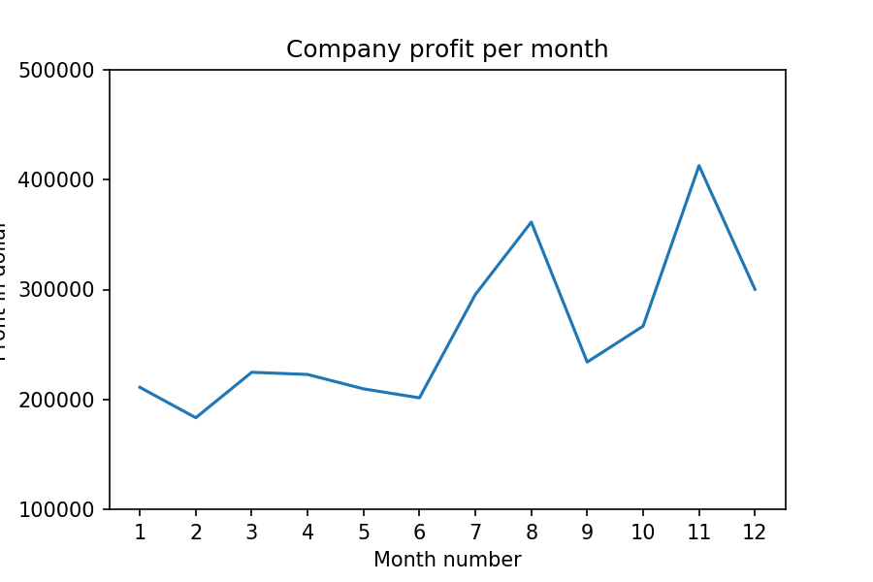

### 

### **Exercise Question 2: Read all product sales data and show it using a multi line plot**

**Display the number of units sold per month for each product using multi line plots. (i.e., Separate Plotline for each product ).**

**The graph should look like this.**

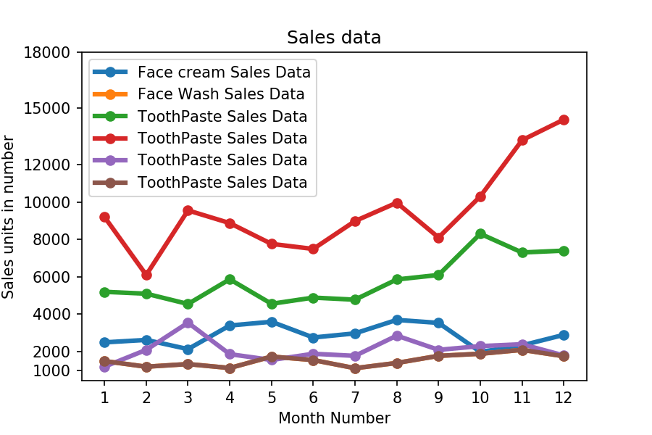

### 

### 

### 

### 

### **Exercise Question 3: Read toothpaste sales data of each month and show it using a scatter plot**

**Also, add a grid in the plot. gridline style should “–“.**

**The scatter plot should look like this.**

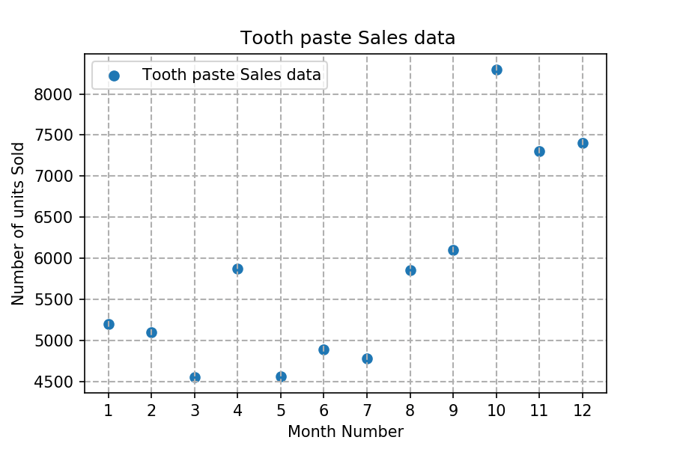

### 

### 

### 

### 

### 

### **Exercise Question 4: Read face cream and facewash product sales data and show it using the bar chart**

**The bar chart should display the number of units sold per month for each product. Add a separate bar for each product in the same chart.**

**The bar chart should look like this.**

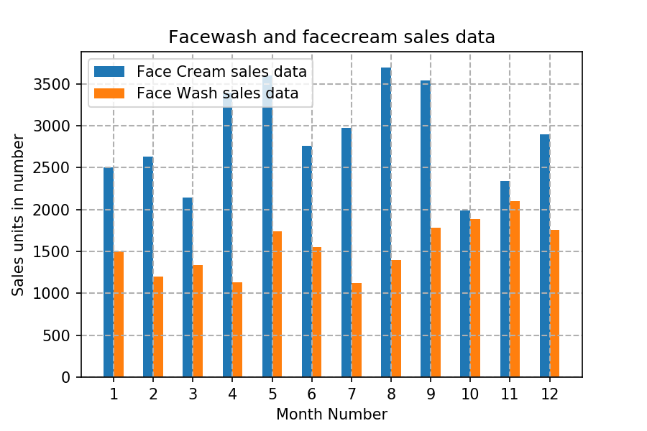

### 

### 

### 

### 

### 

### **Exercise Question 5: Calculate total sale data for last year for each product and show it using a Pie chart**

**Note: In Pie chart display Number of units sold per year for each product in percentage.**

**The Pie chart should look like this.**



 

 

 